# C2- S5 - PRACTICE

*NOTE: check your* ***THEORY slides*** *to answer those questions!*

# EXERCISE 1 – GOOGLE CLASSROOM DATABASE

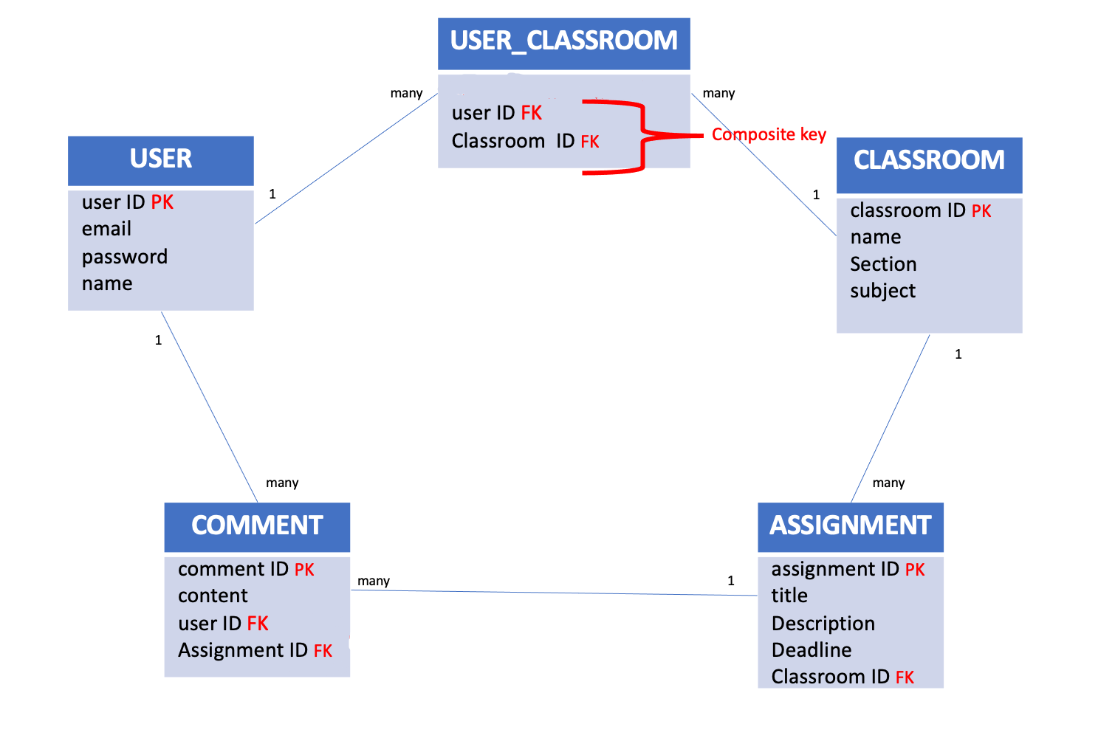

Here is the Entity Relation Diagram of the Google Classroom Database you designed in Chapter 1. You are now going to put it in MySQL!

**Q1 –** Write a statement to create the google classroom database, and to tell MySQL you are now working with it.

* Create database, show database and use it.

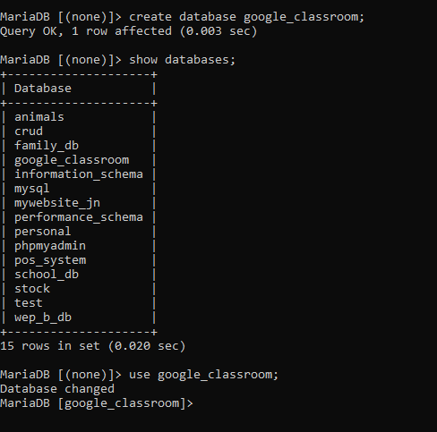

**Q2** – For each table (USER, USER_CLASSROOM, CLASSROOM, ASSIGNMENT, COMMENT), complete the following arrays, by specifying for each attribute:

* + The attribute type (SQL type) and size
  + Can be null or not?
  + Is a primary key or foreign keys?
* **USER TABLE**

|  |  |  |  |
| --- | --- | --- | --- |
| Attribute name | Type / size | Can be Null? | Key |
| User ID | Int (11) | No | PK |
| email | Varchar(50) | Yes |  |
| password | Varchar(30) | Yes |  |
| name | Varchar (20) | Yes |  |

**USER_CLASSROOM TABLE**

|  |  |  |  |
| --- | --- | --- | --- |
| Attribute name | Type / size | Null? | Key |
| User ID | Int(11) | No | FK |
| Classroom ID | Int(11) | No | FK |
|  |  |  |  |

**CLASSROOM TABLE**

|  |  |  |  |
| --- | --- | --- | --- |
| Attribute name | Type / size | Null? | Key |
| Classroom Id | Int(11) | No | PK |
| Name | Varchar(20) | Yes |  |
| Section | Varchar(50) | Yes |  |
| Subject | Varchar(40) | Yes |  |

**ASSIGNMENT TABLE**

|  |  |  |  |
| --- | --- | --- | --- |
| Attribute name | Type / size | Null? | Key |
| Assignment ID | Int(11) | No | PK |
| Title | Varchar(30) | Yes |  |
| Description | Varchar(30) | Yes |  |
| Deadline | Datetime(20) | Yes |  |
| Classroom ID | Int(11) | No | FK |

**COMMENT TABLE**

|  |  |  |  |
| --- | --- | --- | --- |
| Attribute name | Type / size | Null? | Key |
| Comment ID | Int(11) | No | PK |
| Content | Varchar(20) | Yes |  |
| User ID | Int(11) | No | FK |
| Assignment ID | Int(11) | No | FK |

**Q3** – Write the SQL statement to create the 5 tables with appropriate properties.

WARNING: Create the tables in the right order to respect the Foreign Key constraints.

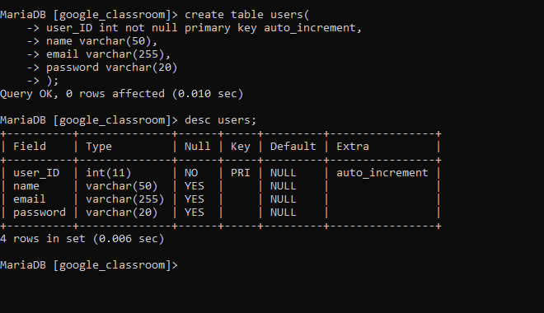

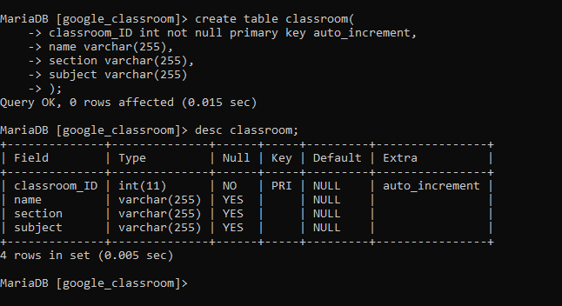

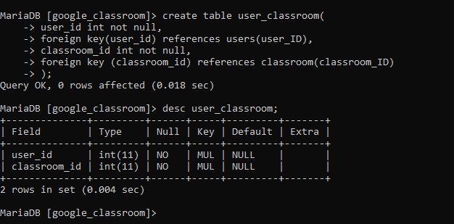

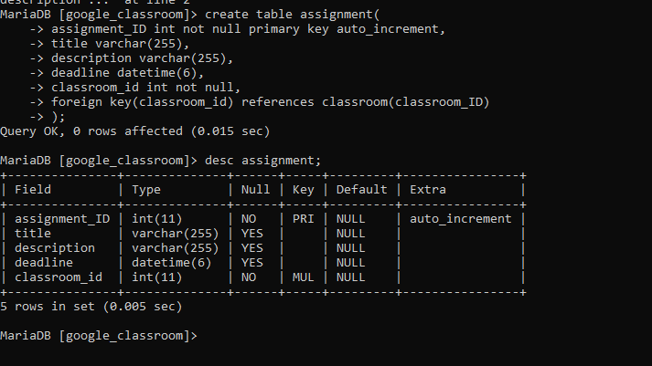

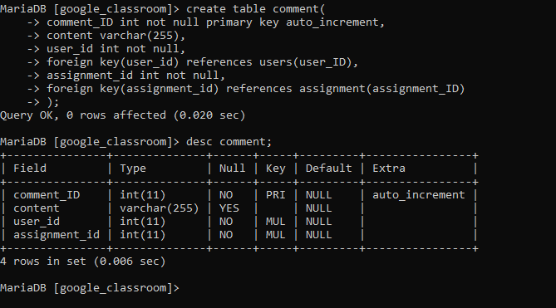

**Q4 –** Write statements to insert at least 3 records in each table.

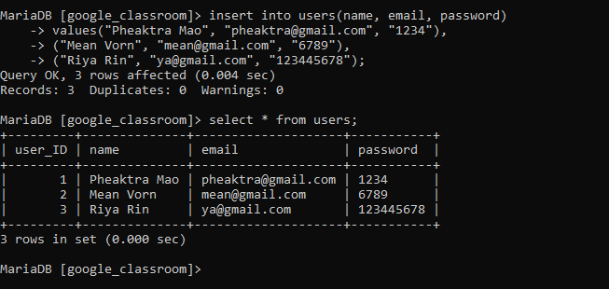

# EXERCISE 2 – FOODPANDA DATABASE

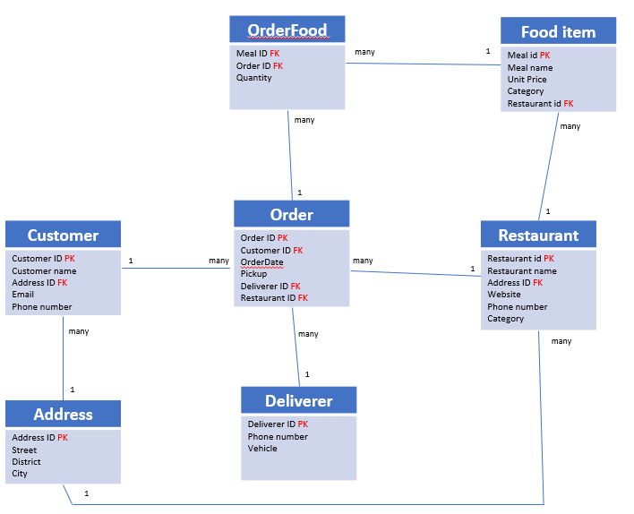

Here is the Entity Relation Diagram of the Foodpanda Database you designed in Chapter 1. You are now going to put it in MySQL!

**Q1 –** Write a statement to create the Foodpanda database, and to tell MySQL you are now working with it.

**Q2** – For each table of the database, complete the following array, by specifying for each attribute:

* + The attribute type (SQL type) and size
  + Can be null or not?
  + Is a primary key or foreign keys?

1. Address Table

|  |  |  |  |
| --- | --- | --- | --- |
| Attribute name | Type / size | Null? | Key |
| Address_Id | Int(11) | No | PK |
| Street | Varchar(15) | Yes |  |
| District | Varchar(30) | Yes |  |
| City | Varhar(30) | Yes |  |

1. Customers Table

|  |  |  |  |
| --- | --- | --- | --- |
| Attribute name | Type / size | Null? | Key |
| Customer_id | Int(11) | No | PK |
| Customer_name | Varchar(20) | Yes |  |
| Address_ID | Int(11) | NO |  |
| Email | Varchar(255) | Yes |  |
| Phone number | Int(11) | Yes |  |

1. Deliverers Table:

|  |  |  |  |
| --- | --- | --- | --- |
| Attribute name | Type / size | Null? | Key |
| Deliver_ID | Int(11) | No | PK |
| Phone number | Int(11) | Yes |  |
| vehicle | Varchar(50) | yes |  |

1. Restaurants Table:

|  |  |  |  |
| --- | --- | --- | --- |
| Attribute name | Type / size | Null? | Key |
| Restaurant ID | Int(11) | No | PK |
| Restaurant Name | Varchar(50) | Yes |  |
| Address ID | Int(11) | No | FK |
| Website | Varchar(255) | Yes |  |
| Phone Number | Int(11) | Yes |  |
| Category | Varchar(255) | Yes |  |

1. Food_items Table:

|  |  |  |  |
| --- | --- | --- | --- |
| Attribute name | Type / size | Null? | Key |
| Meal_ID | Int(11) | No | PK |
| Meal Name | Varchar(50) | Yes |  |
| Unit Price | Varchar(10) | Yes |  |
| Category | Varchar(50) | Yes |  |
| Restaurant_id | Int(11) | No | FK |

1. Orders Table:

|  |  |  |  |
| --- | --- | --- | --- |
| Attribute name | Type / size | Null? | Key |
| Order ID | Int(11) | No | PK |
| Customer_ID | Int(11) | No | FK |
| OrderDate | date | Yes |  |
| PickUp | Boolean | Yes |  |
| Deliver_ID | Int(11) | No | FK |
| Restaurant_ID | Int(11) | No | FK |

1. Order_food Table:

|  |  |  |  |
| --- | --- | --- | --- |
| Attribute name | Type / size | Null? | Key |
| Meal_ID | Int(11) | No | FK |
| Order_ID | Int(11) | No | FK |
| Quantity | Int(11) | No |  |

**Q3** – Write the SQL statement to create the tables with appropriate properties.

WARNING: Create the tables in the right order to respect the Foreign Key constraints.

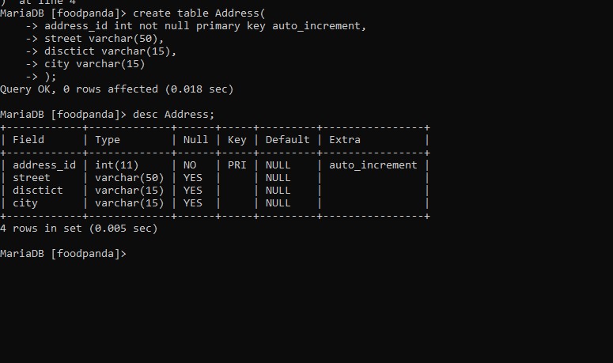

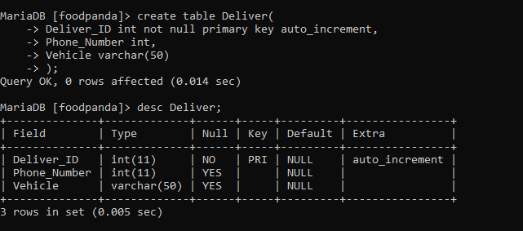

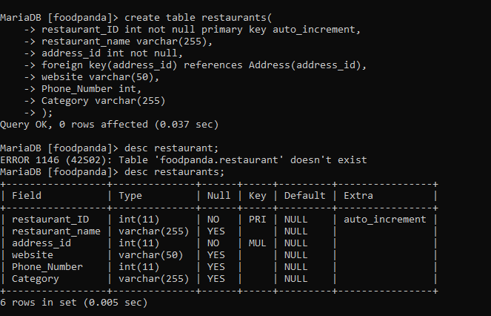

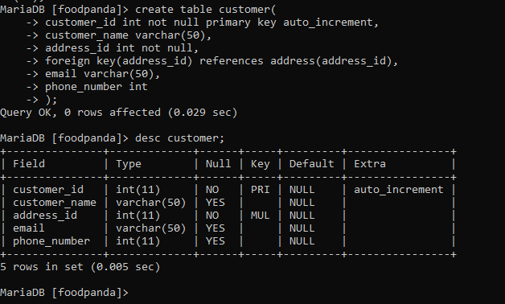

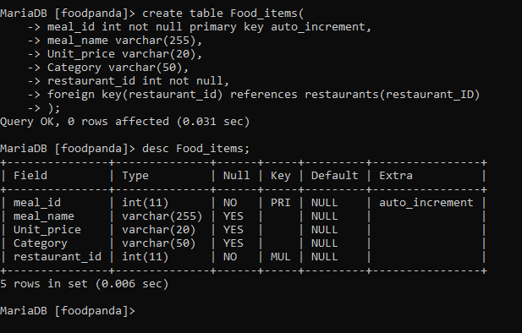

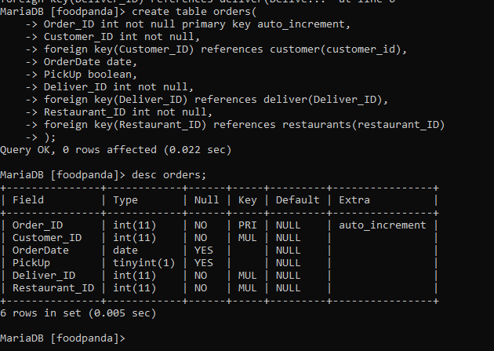

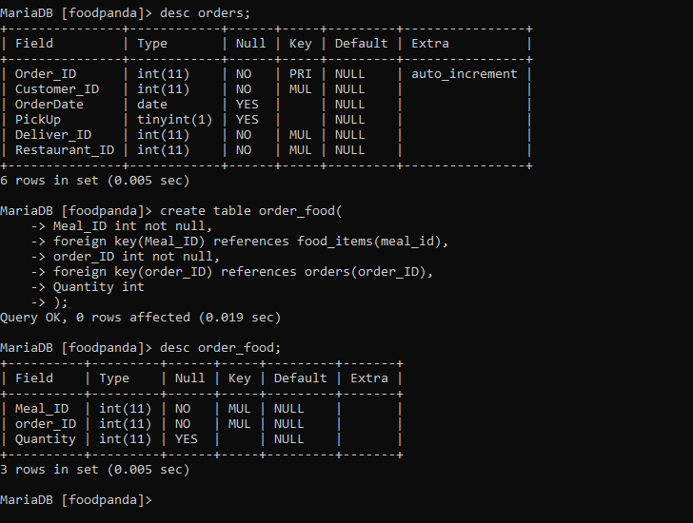

**Q4 –** Write statements to insert between 2 and 4 records in each table.